Building Student Resilience to Maximize Graduation

Rachel Baker
Associate Director of Special Education
Fayette County Public Schools
Rachel.baker@fayette.kyschools.us
859.339.8048

Key words: Resilience, Graduation, Special Education

Funding Sources:

Fayette County Public Schools

Project Cost and Budget Narrative:
Project created as part of normal staff responsibilities. Minimal additional funding for professional learning session materials. Teachers who attend will receive Professional Development Credit.

Project Description:

Graduation rates of students with learning and behavior disabilities have long been a concern nationwide. In school year 2017–18, the national adjusted cohort graduation rate (ACGR) for public high school students was 85 percent, the highest it has been since the rate was first measured in 2010–11 (National Center for Education Statistics – NCES); Kentucky’s overall ACGR was 90%. According to that same database, students with disabilities in the United States have an ACGR of 67%, while Kentucky’s students with disabilities have an ACGR of 75%. In 2019-20 Fayette County Public School’s 4-year cohort graduation of students with IEPs was 73.4%, while the state average of the same population was 78% (Kentucky School Report Card).

Our project began with the lofty ideas of educating administrators, teachers and any other stake holders that would listen, about the 15 Effective Strategies for Dropout Prevention. In an ideal world, starting from the top down with an all-inclusive, long-range plan to build the structures for student support utilizing the 15 Effective Strategies would be optimal. However, as we engaged in the project, the reality of some limitations became apparent. While some teachers serve in leadership roles, many do not have the power or position to implement a system-wide change. While learning about the 15 Effective Strategies for Dropout Prevention and the Trauma Skill Schools Model simultaneously, those two paths came to a crossroads: what action can our High School Special Education Leadership Team take to make the biggest impact for our students and their graduation rates? How can we do this? Based on survey and interview feedback, it became apparent that the greatest potential gain for us would be for the team to zero in on the Professional Development Strategy in which we would target RESILIENCE. How do we build RESILIENCE SKILLS in our students? What do our teachers know about RESILIENCE and its impact on graduation? These questions and our data led us through the development of our 30/60/90 Day Plan Phase1 and Phase 2 for Dropout Prevention which ultimately identified and focused on the need for Professional Learning, implementation and monitoring over time.

Staffing Pattern:

This project was implemented as a team of three: 1) Rachel Baker, Associate Director of Special Education for High Schools & Special Programs 2) Aslean Hoskins, High School Behavior Resource Specialist and 3) Sandy Owens, High School Academics Resource Specialist. This was incorporated into the regular workload as part of the High School Special Education Support Team. The team developed and implemented all phases of the project.

Population Served:
High School Learning and Behavior Disorders Special Education Students 9-12 in Fayette County Public Schools, Lexington, Kentucky (Phase 1)

All students Pre-school through High school in Fayette County Public Schools, Lexington, Kentucky (Phase 2)
Project Origination:
Project created by: Rachel Baker, Aslean Hoskins, and Sandy Owens in response to Cohort 4 Students with IEPs Graduation Rates. While FCPS is trending in the right direction, we remain behind the state average. Based on analysis of YOYO data, the students who are graduating are having better post-secondary outcomes, so our focus needs to zero in on maximizing the number of students who graduate within the 4-year cohort.

Issues Addressed:
- Graduation Rates of Students with Learning and Behavior Disabilities
- Resiliency Skills of Students with Learning and Behavior Disabilities
- Professional Development
- Action Planning, Implementation and Follow-Up
Desired Outcomes and Measurable Objectives:
In the first 30 days, we will know we are successful when:
• We have developed tools to gather baseline data from: teachers, students & parents

In 60 days, we will know we are successful when:
• We have distributed and collected data from teachers, students & parents using developed tools

In 90 days, we will know we are successful when:
• We have analyzed the data and created a prioritized list of Professional Learning needs related to the 15 Strategies for Dropout Prevention

In 120 - 150 days, we will know we are successful when:
• We have planned and developed Professional Learning based on Prioritized Professional Learning List from above

In 180 days, we will know we are successful when:
• We have provided Professional Learning Opportunities for teachers on Building Resiliency Skills to Maximize Graduation Rates

Strategies and/or Interventions of the Project:
First 30 days action strategies:
• Meet to determine objectives for each tool
• Meet to determine type of tool that will be used to collect data
• Meet to determine consistent number of questions for each tool
• Determine who will be responsible to draft each tool
• Meet for peer review of tools, make revisions as necessary

60 days action strategies:
• Send (email) surveys to teachers, parents & students
• Send clear, simple instructions with survey
• Provide positive reinforcer for school/program with highest completion rate
• Monitor return/completion rates
• Send reminders as needed

90 days action strategies:
• Meet to analyze data from surveys
• Create Prioritized Professional Learning Objectives targeting Managing & Improving
Instruction

120 – 150 days action strategies:
• Develop Professional Learning: Building Resiliency Skills to Maximize Graduation
• Advertise & Recruit for Upcoming Professional Learning Opportunity

180 days action strategies:
• Deliver Professional Learning: Building Resiliency Skills to Maximize Graduation

Results (Outcomes and Achievements):
All special education teachers had access to the Building Resilience to Maximize Graduation Professional Development opportunity. This was a blended option that included a course in Canvas in which participants watched screencasts, read documents, reviewed slide decks, and participated in the quiz to demonstrate mastery. As part of that quiz, participants were required to upload their next-steps plan.

All administrators who participated in the Superintendent’s Leadership Institute had opportunity to attend the session which included a review of the 15 Effective Strategies for Dropout Prevention and a Deep Dive into Mentoring in which presenters modeled how to evaluate current level of implementation of a strategy and plan for next step. Follow-up sessions will be based upon participant feedback regarding areas of interest for the strategies.

See data outcomes below:

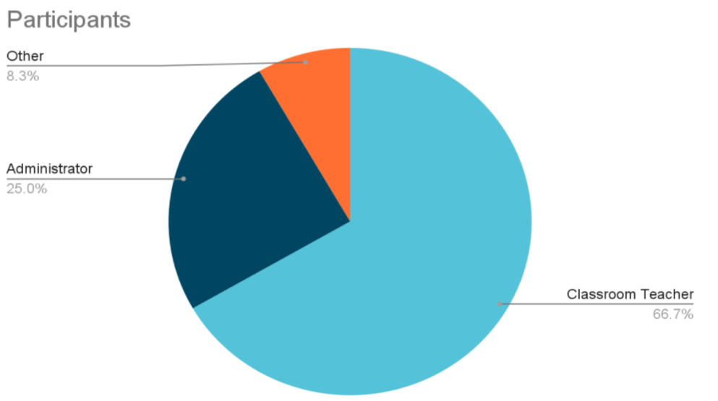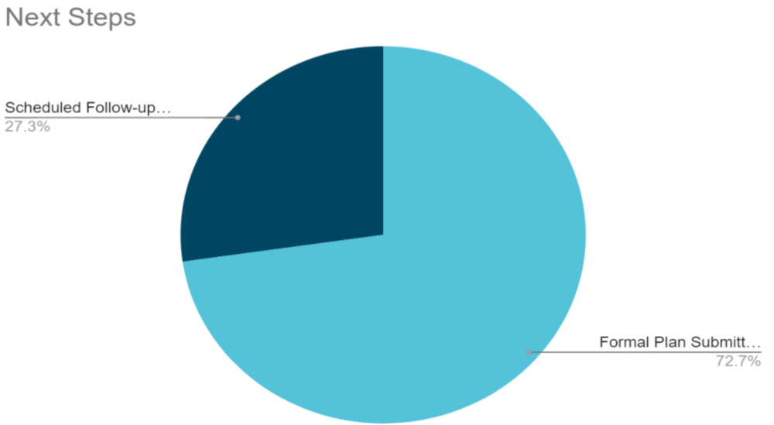

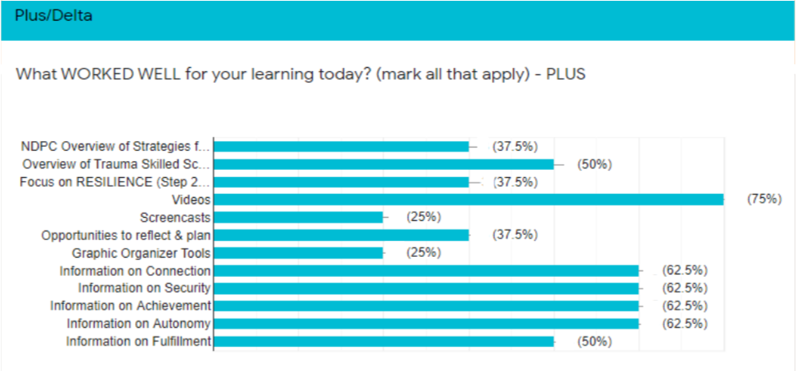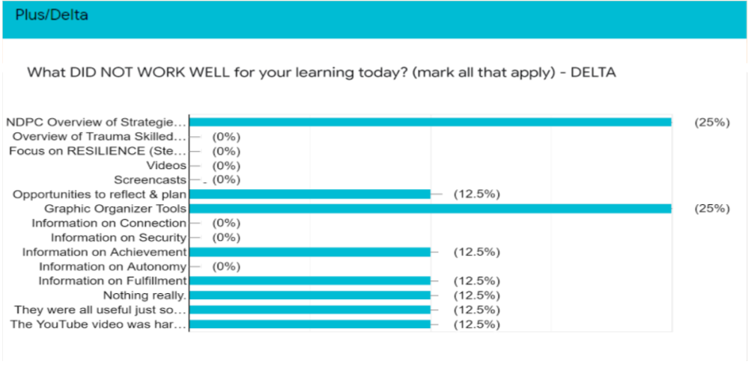

Project Timeline:
30/60/90 Day Plan (Phase 1 of 2)
Key component: Dropout Prevention
Horizon goal: Increase the percentage of students with disabilities graduating within their four-year cohort.
180-day goal: Use data and input from stakeholders to design and implement a plan to provide professional learning to staff in order to increase the use of evidence-based practices in grades 9-12 to increase the percentage of students with disabilities graduating within their four-year cohort
In the first 30 days, we will know we are successful when:
- We have developed tools to gather baseline data from: teachers, students & parents
- Timeline: 8/31/20-10/14/20
The measures/evidence we will use are:
- We will know we are successful when we have developed 3 out of 3 tools to collect baseline data
First 30 days action strategies: | Who is on point | By when | Communicated
- Meet to determine OBJECTIVES FOR SURVEYS | S. Owens  A. Hoskins | 10/14/20 | In 10/7/20 work session
- Meet to determine type of tool that will be used to collect data | S. Owens  A. Hoskins | 10/14/20 | In 10/7/20 work session
- Meet to determine consistent number of questions for each tool | S. Owens  A. Hoskins | 10/14/20 | In 10/7/20 work session
- Determine who will be responsible to draft each tool | TEACHER SURVEY RESULTS  A Hoskins | 10/14/20 | via email to R. Baker
- Determine who will be responsible to draft each tool | STUDENT SURVEY  PARENT SURVEY  S. Owens | 10/14/20 | via email to R. Baker
- Meet for peer review of tools, make revisions as necessary | R. Baker  A. Hoskins  S. Owens | 10/14/20 | Tools will be shared via email. If revisions are necessary, group will meet on 10/14/20
If we are not successful, we will:

- Adjust timelines as necessary - group met and decided a guidance counselor survey. Copies may made to provide to different grade level teachers/parents etc.

In 60 days, we will know we are successful when:
- Note: Due to COVID 19 and multiple surveys being sent to parents and students regarding in-person learning vs. virtual learning and many other stakeholder surveys from the district, we revised our plan to only survey teachers at this time.

- We have distributed and collected data from teachers using developed tools.
- Timeline: 10/15/20-12/1/20
The measures/evidence we will use are:
- We will know we are successful when we have a minimum of 70% participation/completion of surveys from teachers
60 days action strategies: | Who is on point | By When | Communicated
- Send (email) surveys to teachers, parents & students | R. Baker | 11/30/20 | Via email asked to complete by the 4th
- Send clear, simple instructions with survey | R. Baker | 11/30/20 | Via email asked to complete by the 4th
- Monitor return/completion rates | A. Hoskins | 1/20/21 | In 1/20/21 Work Session
- Send reminders as needed | R. Baker | 1/20/21 | Via email from R. Baker
If we are not successful, we will:
- Adjust timelines as necessary

In 90 days, we will know we are successful when:  - We have analyzed the data and created a prioritized list of Professional Learning needs related to the 15 Strategies for Dropout Prevention  - Timelines: 12/2/20 - 1/27/21 | R. Baker  A. Hoskins  S. Owens | 1/27/21 | In 1/27/21 Work Session
The measures/evidence we will use are:  - Prioritized list for Professional Learning targeting Managing & Improving Instruction | A. Hoskins  S. Owens | 1/27/21 | In 1/27/21 Work Session
90 days action strategies: | Who is on point | By when | Communicated
- Meet to analyze data from surveys | R. Baker  A. Hoskins  S. Owens | 1/27/21 | In 1/27/21 Work Session
- Create Prioritized Professional Learning Objectives targeting Managing & Improving Instruction | R. Baker  A. Hoskins  S. Owens | 1/27/21 | In 1/27/21 Work Session
If we are not successful, we will:
- Adjust timelines as necessary

Phase 2 of 2 – The Next 90 Days:
120 Days (1/28/21 - 3/11/21)
- Plan and Develop Professional Learning based on Prioritized PL List from above.
- Complete National Dropout Prevention Certification by completing online courses.

150 Days (3/12/21 - 4/30/21)
- Continue to Plan and Develop Professional Learning based on Prioritized PL List from above.
BUILDING RESILIENCE TO MAXIMIZE GRADUATION
Connection
Security
Achievement
Autonomy
Fulfillment

180+ Days (5/3/21 - 6/14/21)
- Provide Professional Learning Opportunities for LBD Teachers
BUILDING RESILIENCE TO MAXIMIZE GRADUATION
Connection
Security
Achievement
Autonomy
Fulfillment
- Superintendent Leadership Institute for district leadership July 13-15, 2021
15 Effective Strategies for Dropout Prevention Overview
Deep Dive: Mentoring

Outcomes Related to School Completion, Dropout Prevention, and/or Graduation Rates:

4 Year Cohort Graduation Rate – Students with IEPs
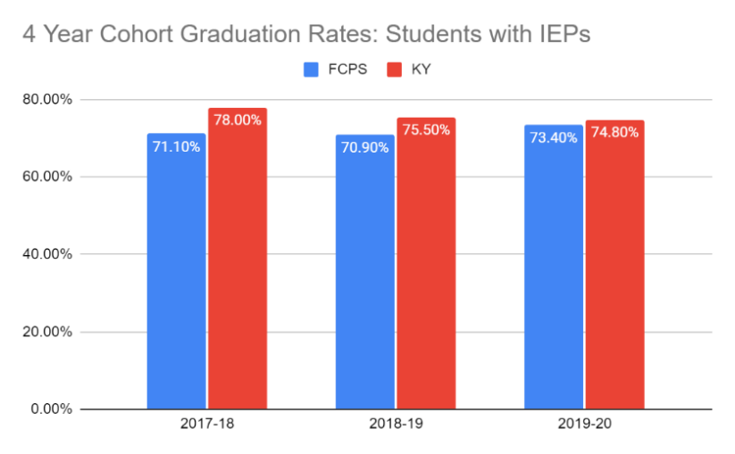

Youth One Year Out (YOYO) Data
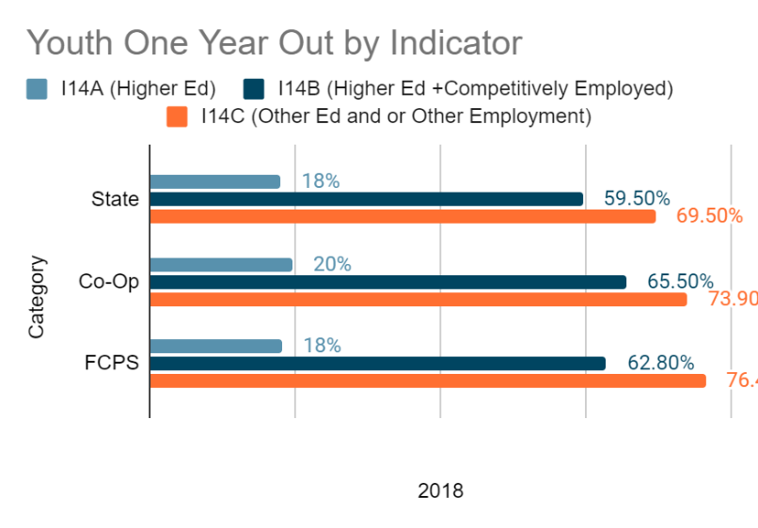
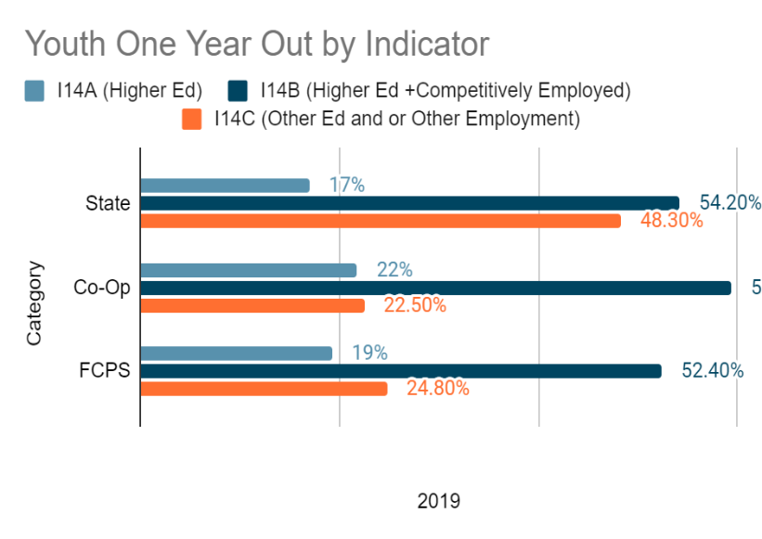

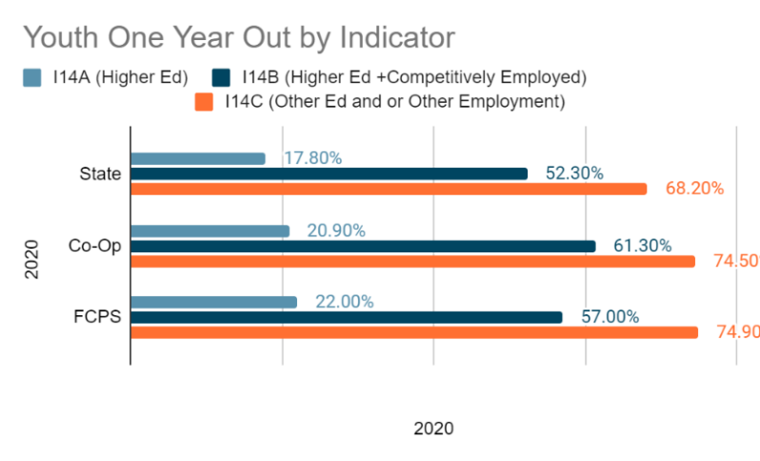

Special Conditions, Expertise, and/or Skills Required to Carry Out Project:
Special Conditions: Our country is currently in the midst of a global COVID 19 Pandemic. Students in Fayette County Public schools have received instruction virtually since March 2020. A very small group of students received targeted services as part of a school plan or as a result of an Admissions and Release Committee (ARC) decision. At this time, students/families have been given the choice of returning to in-person learning or virtual learning. Even with the return of in-person learning, virtual learning, and targeted services, no one knows the mental or academic impact and long-term effect this pandemic will have on many facets of education, including graduation rates.

Expertise/Skills:
- Knowledge of the 15 Effective Dropout Prevention Strategies and the Trauma Skilled Schools Model are critical to project implementation.
- Presentation development and implementation skills
- Knowledge of Action Planning & Implementation
- Coaching skills to support programs desiring to implement action plan.
Current Status of Project:
Professional Development Summer 2021
We will be providing the High School LBD Building Resilience to Maximize Graduation Professional Development Opportunity over the summer, through a blended (asynchronous/synchronous) model. The training is housed in Canvas and individuals work their way through screencasts, Google slide decks, graphic organizers and development of an action plan as they develop their knowledge in the components of Resilience. Once completed, participants may attend an optional workshop in late July to ask questions, collaborate with their team, develop action plans, etc.

All PD offered for high school special educators is now aligned to the appropriate NDPC category and strategy.

Superintendent’s Leadership Institute
A proposal to present at the FCPS Superintendent Leadership Institute knowing that system-wide change will bring the best student outcomes. The proposal was approved, and the offering was presented on July 13 & 14, 2021.

As the audience was different (primarily building leadership), the decision was made to do an overview of the 15 Effective Strategies for Dropout Prevention and model through lecture, group work, use of graphic organizers and rubric and evaluation of one of the strategies (Mentoring) in order to provide attendees the structure for review of where they are regarding a particular strategy and make a next steps plan.

Role in Project as a NDPS Certification Program Participant:
As part of our project, I worked to gather data, develop surveys, and construct a 30 60 90-day plan for implementation at a district level. I worked to provide instructions and a systemic approach for gathering the data during each phase. As we reviewed the data, I worked on developing a professional development to be delivered this summer to open the 21-22 school year. The professional development involved interactive opportunities for schools to reflect current programming and begin to make connections with the 15 effective strategies.

Lessons Learned:
The lessons I learned focus on the interdependence of the strategies and the impact they can have on focusing district level initiatives. As I engaged in deep learning of each strategy, I developed a webbing of the district plan. At first, the task seems overwhelming but by chunking the concepts into smaller sections, I could see how our district could begin to pull people together with a common goal. This offers the opportunity to transform my district’s strategic plan. Schools will have the opportunity to reflect and research model programs to enhance, rebuild or create a unique program to address their school needs assessments.

Advice for Dropout Prevention Practitioners about the Project:
Always begin with reflection. I believe we do not give people enough time to discuss what they know and what they do not know. The project allows for a continuous feedback and reflective loop so programs can begin, grow, and reimagine what they need to do to reach kids and families.

