Certificate of Completion
Alison Kreitzer
Has completed the requirements for

NATIONAL DROPOUT PREVENTION CENTER
TRAUMA-SKILLED SPECIALIST CERTIFICATION
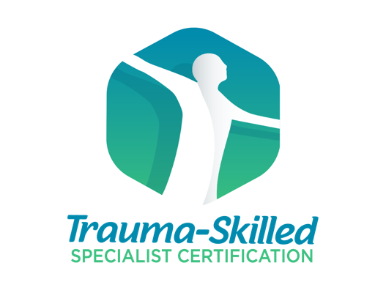
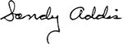
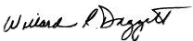

______________________________ ______________________________
Dr. Bill Daggett Dr. Sandy Addis
Founder and Chairman Director


Issued February 2022

