National Dropout Prevention Network
Crystal Star Award of Excellence in Dropout
Recovery, Intervention, and Prevention Nominations

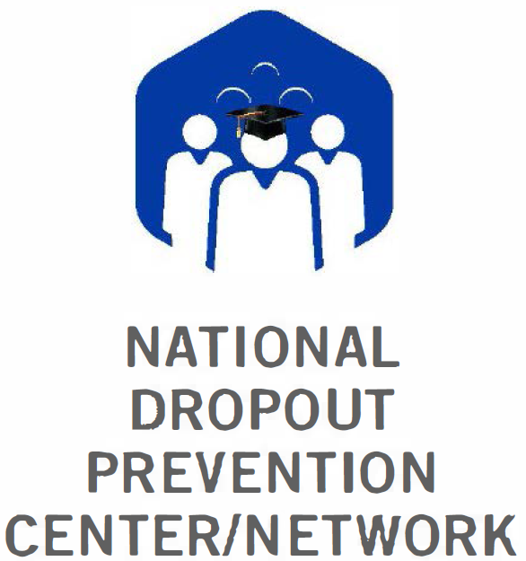

Nominations for the National Dropout Prevention Network Crystal Star Award of Excellence in Dropout Recovery, Intervention, and Prevention are now being accepted. We need your help in identifying and honoring outstanding programs and individuals in the field of dropout prevention. This packet contains all nomination forms for both Program and Individual Award nominations.

The purpose of the National Dropout Prevention Network (NDPN) Award of Excellence in Dropout Recovery, Intervention, and Prevention is to identify and bring national recognition to outstanding programs or individuals that have made significant contributions to the advancement of the mission of the NDPN.

The Crystal Star Awards of Excellence in Dropout Recovery, Intervention, and Prevention are open for nominations from anyone active in the field of dropout prevention. For a program or individual to be recognized, there must be a clear evidence of accomplishments contributing to effective dropout prevention strategies and work that furthers the mission of the Network.

Nominations Due: July 1, 2017

Forms and documents should be scanned and submitted electronically to John Gailer at jgailer@clemson.edu. Questions and comments should be directed to John Gailer via email, jgailer@clemson.edu or telephone, 864-656-2675.

National Dropout Prevention Center/Network

Clemson University, 209 Martin Street, Clemson, SC 29631-1555
864-656-2599, FAX: 864-656-0136, ndpc@clemson.edu, www.dropoutprevention.org

Individual Award Criteria and Instructions

In order to be nominated for a Crystal Star Award of Excellence in Dropout Recovery, Intervention, and Prevention, an individual must be an established professional with at least seven years of service in the area of dropout prevention. This service can be in a formal education system or with a nonprofit or community-based agency. Each member of the nominating team must have a minimum of three years of service in the field of dropout prevention. Nominees for the award must have contributed toward the demonstrable success of a program in the area of dropout recovery, intervention, or prevention.

Instructions
- Nominations for an Individual to receive a Crystal Star Award of Excellence must be made by a team of at least three individuals with at least three years in the field.
- The nominating team should complete the “Individual Nomination Form.”
- Each member of the team must send an email explaining their own reasons for supporting the nomination. These emails or letters of support are considered confidential to the panel of judges that evaluate the nomination.
- Together, the nominating team should submit a narrative highlighting at least three examples of the nominee’s exemplary practices from those listed below (please use the phrase describing the criteria chosen as the header for that section). The narrative should incorporate evidence of success of the nominee’s efforts and service and be no more than five pages in length. The ideal candidate for a Crystal Star Award performs his/her job in an exemplary manner, provides strong leadership in dropout prevention efforts, and:
- establishes a continuing process of evaluating goals and objectives to provide an organizational structure that allows each school to develop a learning environment which ensures quality education for all students
- works effectively with all groups in the community to create a caring and supportive environment where youth can thrive and achieve
- works effectively to create a safe environment for learning works to develop and initiate family engagement promotes early childhood education
- works to develop, promote, and implement literacy
- works to develop and implement mentoring and tutoring programs
- works effectively with at-risk students, teachers, administrators, parents, and the community to involve students in service-learning activities
- works to develop and implement alternative learning environments for at-risk students
- promotes after-school opportunities to expand the knowledge base of at-risk students
- promotes and implements professional development programs focused on issues related to teaching and working with at-risk students
- works to develop and initiate active learning methods of instruction to help at-risk students find new and creative ways to solve problems, achieve success, and become lifelong learners
- works effectively to integrate technology into the curriculum and also to provide enrichment opportunities for students
- works to develop and initiate an individualized learning plan for at-risk students
- establishes career and technology programs that recognize that youth need specific skills to prepare them to measure up to the larger demands of today’s workplace

- The Individual Nomination Form and narrative must be emailed together prior to the deadline for award nominations. Supportive emails must arrive separately from the email address of the writer prior to the deadline for award nominations.

A panel of judges will review each individual nomination for the Crystal Star Awards of Excellence in Dropout Recovery, Intervention and Prevention according to the criteria and process listed above. The Crystal Star Awards will be presented at the National Dropout Prevention Network Conference. Award winners will be provided with free registration for the conference and complimentary one night’s stay in the conference hotel.

Crystal Star Awards of Excellence Individual Award Nomination Form

Please refer to the Individual Award Criteria and Instructions for submitting your nomination.
Nominee’s Name: |  |  |  |  |  |  |  |  |  |  | Position:
Agency/School District:
Address:
City/State/Zip Code: |  |  |  |  |  |  |  |  |  |  |  | Telephone:
Fax: |  |  |  |  |  |  |  | E-mail:
Years of Service in Dropout Prevention:
With what Agencies:

PERSON SUBMITTING NOMINATION:
Name: |  |  |  |  |  |  |  |  |  |  |  |  | Position:
Agency/School District:
City/State/Zip Code: |  |  |  |  |  |  |  |  |  |  |  |  |  | Telephone:
Fax: |  |  |  |  |  |  |  |  |  | E-mail:
Years in Service: |  |  |  |  |  |  | Where?

SUPPORTING NOMINATION: (required)
Name: |  |  |  |  |  |  |  |  |  |  |  |  | Position:
Agency/School District:
City/State/Zip Code: |  |  |  |  |  |  |  |  |  |  |  |  |  | Telephone:
Fax: |  |  |  |  |  |  |  |  |  | E-mail:
Years in Service: |  |  |  |  |  |  | Where?

SUPPORTING NOMINATION: (required)
Name: |  |  |  |  |  |  |  |  |  |  |  |  | Position:
Agency/School District:
City/State/Zip Code: |  |  |  |  |  |  |  |  |  |  |  |  |  | Telephone:
Fax: |  |  |  |  |  |  |  |  |  | E-mail:
Years in Service: |  |  |  |  |  |  | Where?

The Individual Nomination Form and narrative must be emailed together prior to the deadline for award nominations. Supportive emails must arrive separately from the email address of the writer prior to the deadline for award nominations. Forms and documents should be scanned and submitted electronically to John Gailer at jgailer@clemson.edu.
Program Award Criteria and Instructions

In order to be nominated for a Crystal Star Award of Excellence in Dropout Recovery, Intervention, and Prevention, a program must have been in operation for a minimum of three years, have empirical data to demonstrate effectiveness, and have implemented at least five of the strategies listed below.

Instructions
- The nominating team or individual should complete the "Program Nomination Form."
- The nominating team or individual should craft a narrative describing the operation and impact of the program nominated. The narrative must be submitted in Microsoft WORD format using 12-point Times New Roman font, single-spaced with one inch margins and should not exceed 10 pages. It should be constructed as follows:
  - Program Abstract (One page, single spaced description of program and statistics demonstrating effectiveness)
  - Program Goals and Purpose
  - Objectives of the Program
  - Target Population
  - Description of the program's use of researched-based strategies. Must address at least five of the following (please use headings for each strategy):
    - Systemic Approach: A continuing process of evaluating goals and objectives related to school policies, practices, and organizational structures as they impact a diverse group of learners is provided.
    - School-Community Collaboration: The program works with a variety of groups in the community to establish collective support for the school and to provide a strong infrastructure to sustain a caring environment where youth can thrive and achieve.
    - Safe Learning Environments: Create a learning environment that provides daily experiences, at all grade levels, which enhance positive social attitudes and effective interpersonal skills in all students.
    - Family Engagement: School planning teams receive training in strategies to help parents and other family members become active and informed partners in helping their children pursue and achieve their educational goals. Family members are involved in workshops and meetings to gain the necessary skills.
    - Early Childhood Education: Students identified as at-risk at a young age receive the best possible classroom instruction from the beginning of their school experience.
    - Early Literacy Development: Early interventions to help low-achieving students improve their reading and writing skills, establishing the necessary foundation for effective learning in all subjects are fostered.
    - Mentoring/Tutoring: One-to-one involvement in a mentoring or tutoring situation is utilized.
      - Service-Learning: Meaningful community service experiences with academic learning, personal growth and civic responsibility are connected.
    - Alternative Schooling: Alternative academic and vocational programs, varied learning environments and flexible scheduling to meet identified needs of students are offered.
    - After-School Opportunities: Students are involved in a variety of activities during after-school or summer sessions: study skills, enrichment events, and accelerated courses.
    - Professional Development: The staff is engaged in professional development activities and research that contribute to exemplary teaching practices in dropout prevention.
    - Active Learning: Students are empowered to find new and creative ways to solve problems, achieve success, and become lifelong learners.
    - Educational Technology: Students are engaged in authentic learning, and technology is used to address multiple intelligences and learning styles.
    - Individualized Instruction: Components are customized to meet the various needs of students and to help students develop responsibility for their own learning.
    - Career and Technical Education: Opportunities are provided to learn the skills necessary to measure up to the larger demands of today's workplace.
  - Indicators of Effectiveness (e.g., improvement in the dropout rate, increased academic achievement, fewer discipline referrals, and/or improved attendance)
  - Evaluation-how the program is evaluated and when it was evaluated
  - Lessons learned-share what you have learned that may benefit others interested in establishing a similar program

- The Program Nomination Form and narrative must be emailed together prior to the deadline for award nominations.

A panel of judges will review each individual nomination for the Crystal Star Awards of Excellence in Dropout Recovery, Intervention and Prevention according to the criteria and process listed above.

Crystal Star Awards of Excellence Program Award Nomination Form

Please refer to the Program Award Criteria and Instructions for submitting your nomination.
Name of Program:
Agency/School District:
Contact Person: |  |  |  |  |  |  |  |  |  |  |  |  |  |  | Position:
Address:
City/State/Zip Code:
Telephone: |  |  |  |  |  |  |  |  |  |  |  | Fax:
E-mail
How long has the program been in operation? |  |  |  |  |  |  |  |  |  |  |  |  | Is it in operation at multiple sites?
Date of last evaluation:
Describe data Used to assess effectiveness:

Person Submitting Nomination:
Name: |  |  |  |  |  |  |  |  |  |  | Position:
Agency/School District:
Address:
City/State/Zip Code:
Telephone: |  |  |  |  |  |  |  | Fax:
E-mail:

Who Should Be Notified of Award Committee’s Decision?
Name: |  |  |  |  |  |  |  |  |  |  | Position:
Agency/School District:
Address:
City/State/Zip Code:
Telephone: |  |  |  |  |  |  |  | Fax:
E-mail:

The Program Nomination Form and narrative must be emailed together prior to the deadline for award nominations. Forms and documents should be scanned and submitted electronically to John Gailer at jgailer@clemson.edu.

